OS Update Certification -   
Digital Modifications Assessment Form

Template

Version 1.0.00

NFC ForumTM

[OSUC_DMAF]

2025-03-14

Copyright © 2025 NFC Forum

This form is to be used in the NFC Forum Certification Program to declare the Digital part changes due to an OS Update For a certified Implementation.

NFC Forum Implementation Operating System Update – Digital Modifications Assessment Form

Template Instructions:

1. Place the content of this document on your company letterhead
2. Items highlighted in yellow should be reviewed and replaced with your information
3. Remove the highlights

[Manufacturer_Name] declares, under its sole responsibility, that the digital modifications due to the OS update are described exhaustively and that the test cases linked to the impacted Test Groups are listed and verified in the included test report. in this document. Digital modifications refer to any modifications performed in the OS related to the implementation of the technical specifications shown below in the green square (all layers except the Analog Specification).

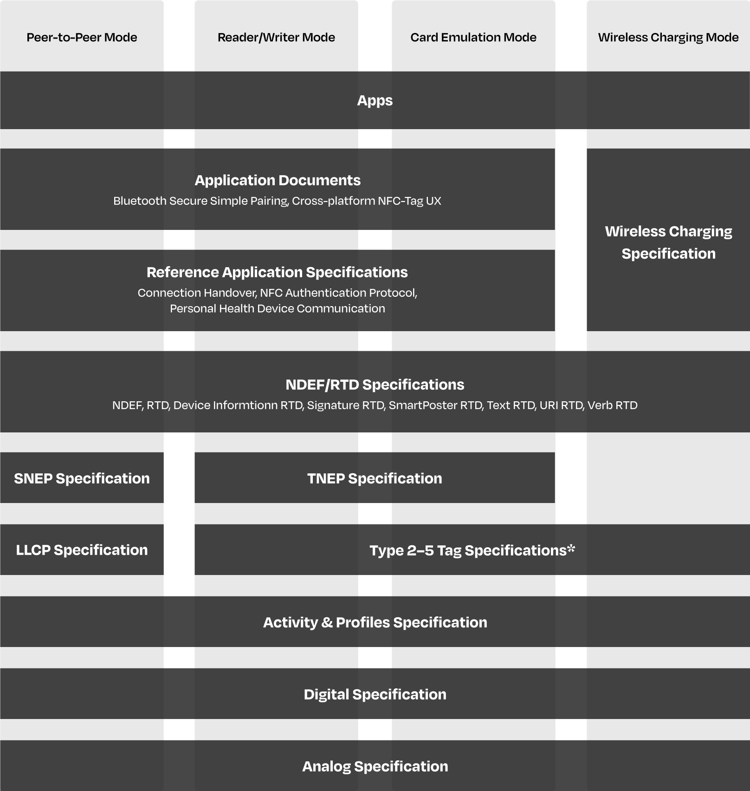

[Manufacturer Name] declares as well, under its sole responsibility, there are no changes to the declared supported or not features in the ICS nor the parameter values in the IXIT, compared to the originally certified device.

| Field | Contents |
| --- | --- |
| Organization Name* | Note: Document should be signed by a senior level management member representing the company |
| Primary Contact | Note: Document should be signed by a senior level management member representing the company |
| Primary Email Address | Note: Document should be signed by a senior level management member representing the company |
| Primary Phone Number | Note: Document should be signed by a senior level management member representing the company |
| Certificate identifier | Note: Supllier provide the certified Implementation identifier executed with a pevious OS version. |
| Certification OS Version | Note: Version of the OS of the Full certification. |
| Update OS Version | Note: Version of the OS update. |
| Certification Release | Note: xxx. |
| Device Class* | NFC Universal Device,  NFC Mobile Device,  NFC Reader Device,  NFC Tag Device,  NFC Card Emulation Device,  NFC WLC Reader Device,  NFC WLC Tag Device,  CCC Digital Key Reader Device,  CCC Digital Key CE Device,  USI WLC Reader Device |
| Digital part changes description | Note: Provide operating system changes and required changes to affected sublayers (API, structure, behavior) and which Test groups are impacted. |
| Results report of impacted Test Groups | Note: Embed the Excel results report file with all test cases associated with the test groups affected by the changes. |
| Signature | Note: Double click on the sign object and add company certificate including information about the signer in details part of the certificate |
| Date | DD/MM/YYYY |

Revision History

The following table outlines the revision history of OS Update Certification -   
Digital Modifications Certification Assessment Form.

Table : Revision History

|  |  |  |  |  |
| --- | --- | --- | --- | --- |
| Document Name | Revision and Release Date | Status | Change Notice | Supersedes |
| NFC Forum OS Update Certification - Digital Modifications Assessment Form | 1.0.00  March 2025 | Final | Initial | - |